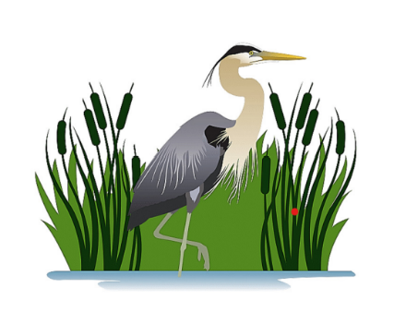
FRIENDS OF MISSISQUOI

NATIONAL WILDLIFE REFUGE
29 Tabor Road, Swanton, VT 05488
802-868-4781
www.friendsofmissisquoi.org
Art on the Refuge
2026 Exhibits for World Migratory Bird Day
Information and Participation Forms

Art Show Opening: May 9, 2026
Exhibit dates: May 9, 2026, through July 10, 2026
Location: Missisquoi National Wildlife Refuge Visitor
Center, 29 Tabor Road, Swanton, VT 05488

The Missisquoi National Wildlife Refuge, along with many conservation organizations, will celebrate World Migratory Bird Day (WMBD) this May. The 2026 theme is “Every Bird Counts - Your Observations Matter” highlighting the critical role of community science in bird conservation.

The Friends of Missisquoi will again be hosting the annual art show AT THE VISITOR CENTER, starting May 9, 2026. Our focus will be birds that reside here or migrate through the area, and the importance of the habitats that support bird populations, including during their migrations. The World Migratory Bird Day campaign’s key message emphasizes how important data collection by members of a community is toward documenting short- and long-term patterns. The Missisquoi National Wildlife Refuge provides habitats for bird observations in our area.

Requirements for work entered in the Art Show:
All pieces must be properly framed, being “ready to hang.” Stretched canvas must have “finished” edges. Each piece is not to exceed 24” x 30” framed, unless it is determined that there is ample space available. Check with Carol Yarnell if your work does not fit the specs, and we will figure out a way to include it. If work is not a framed piece (such as stained glass), please make sure there is a way to hang it on the hooks provided by the Refuge.
Medium: Suggestions, though not limited to this list: acrylics, pen and ink, pastels, wood, oil, watercolor, wool, photographs, natural plant materials, fabric, stained glass.
Paintings/drawings, etc.: Subjects may be birds* or anything related to what might be found in a landscape that helps birds in their migration, breeding, etc. at the Refuge: lake, river, marsh, forest, wildlife, wildflowers/plants, fields, etc. and interpretations of any of these.
Photographs: Preference is for photos taken on the Refuge but may be from other sites that are local breeding, wintering, or stopover areas for birds* found on the Refuge.
*Ebird list for Missisquoi National Wildlife Refuge is included in this packet.
Entry fee: $15 per piece; one may enter 2 works if desired. The entry fee will provide the artist with a year’s membership in the Friends of Missisquoi. A second fee can be earmarked for a membership for a second person chosen by the artist.
Sales will pass through the Friends gift/bookstore. We request that the artist replace the item sold with another work at no charge. We do not charge a commission for the sale of art in the show, but a donation to the Friends group to help support the Missisquoi National Wildlife Refuge is always welcome and appreciated.

Art Drop-Off at Refuge Visitor Center hours:
Evening Art Drop-off: 6:00 to 7:00 pm on May 5^{h} (Tuesday)
Daytime/Weekday Drop-off: 8:00 am to 4:00 pm.
Because our staff may be out doing fieldwork, it is important to call the Refuge Visitor Center to confirm someone is there to receive your artwork. Call 802-868-4781 before all art drop offs!
If you need to make other arrangements, such as on a weekend, please contact Carol Yarnell: artshow@friendsofmissisquoi.org or 802-324-6939.

Drop off alternate site options:
Drop-off at Village Frame Shoppe, St. Albans - requirements:
- The artwork must be labeled for the Missisquoi Refuge Art Show.
- While care will be taken in receiving and storing of artwork, the artist understands that the Shoppe is not responsible for any loss or damage that might occur.
- Drop off Tuesday - Friday between the hours of 11-3, Saturday 11-1, BEFORE or ON May 5th.
Drop-off at Swanton Public Library - requirements:
- The artwork must be labeled for the Missisquoi Refuge Art Show.
- While care will be taken in receiving and storing of artwork, the artist understands that the Swanton Public Library is not responsible for any loss or damage that might occur.
- Drop off hours are as follows: Monday, Wednesday, Friday: 10am-6pm. Tuesday, Thursday, Saturday: 10-2. Please drop off by May 5th.

Missisquoi National Wildlife Refuge - Art on the Refuge Participation Form

Artists: please read the following carefully. Please fill in all the blank spaces (where applicable) on this form, sign, and date. If you have any questions, please contact: Carol Yarnell: artshow@friendsofmissisquoi.org
For more copies of this form and more information: https://friendsofmissisquoi.org/artshow/
Name: _____________________________________________________________________________________________
Address: _____________________________________________________________________________________________
Town, State, Zip: _____________________________________________________________________________________________
Email: ____________________________________________ Phone: _______________________________________
Artwork Title and Size Bird Species Medium Price
1. ____________________________________________________________________________________________________________
2. ____________________________________________________________________________________________________________
Hanging Fee: $15 per art piece. No sales commission fees unless a donation is offered upon sale. MAKE CHECKS PAYABLE TO FRIENDS OF MISSISQUOI.
The entry fee will provide the artist with a free one-year membership in Friends of the Refuge. For current Friends members and for second entries, we encourage you to donate a one-year membership to a family member or friend. Just provide us with the name and address/email. Second membership is for:
_____________________________________________________________________________________________________________________
A quarterly newsletter will be sent to all members. All newsletters will be delivered via email - if you prefer it to be sent via US mail please check box and provide mailing address below
Yes, I prefer a printed copy of the Friends newsletter to be mailed to me.
Mailing address: __________________________________________________________________________________________________________
2nd mailing list: ___________________________________________________________________________________________________________
Participation form and entry fee should be sent ahead of the show or art drop off. (Make checks payable to Friends of Missisquoi.)
Address: Missisquoi National Wildlife Refuge Attn: Friends of Missisquoi Art Show, 29 Tabor Road, Swanton, VT 05488.
By signing this form:
I agree to hold harmless the Friends of Missisquoi National Wildlife Refuge, Inc. and the Missisquoi National Wildlife Refuge for any loss, or damage to my artwork due to hanging or holding, and during the length of the exhibition for the Art on the Refuge project at the Missisquoi National Wildlife Refuge.
Signature: _______________________________________________________________________________________________________
Printed Name: ____________________________________ Date: __________________________

2026 Missisquoi NWR Art Show instructions for Wall-Tags and Artist Bio
Please use 1 wall-tag template for each art piece you enter in the show. Once filled out, each wall-tag can be cut out and posted on the lower right side of your artwork. These wall-tags provide information about your piece that interested buyers can use to inquire about your artwork.

The Artist Bio:
Additionally, there is an Artist Bio template (1 Bio per artist). Using the Artist Bio template to give a brief description of your process as an artist will enhance interest in your work and add to the professionalism of your presentation.
Those that offered theirs last year offered some fascinating background for the art and the artist. Your “bio” can be tailored in whatever way you would like to introduce yourself. It can include your interest in birds, your background, or other information you would like to present to let the public know about you as an artist. It can even link to your own website or blog if you’d like.
We thank you for your participation. If you have any questions, please contact Carol Yarnell at: artshow@friendsofmissisquoi.org.

Note: There is a space on the bottom of the wall tags stating “donating ( )% of sale to Friends Of Missisquoi”. If you are donating part of your sales to Friends Of Missisquoi, please fill in the percentage to let potential buyers know you are contributing to the conservation of the Missisquoi National Wildlife Refuge, however, donations are not mandatory. If you are not donating, just delete the line from the bottom of the tag. If you are hand-editing the PDF version of the wall tags and you choose to donate a portion of your sales, just hand write it on the bottom of the tag.

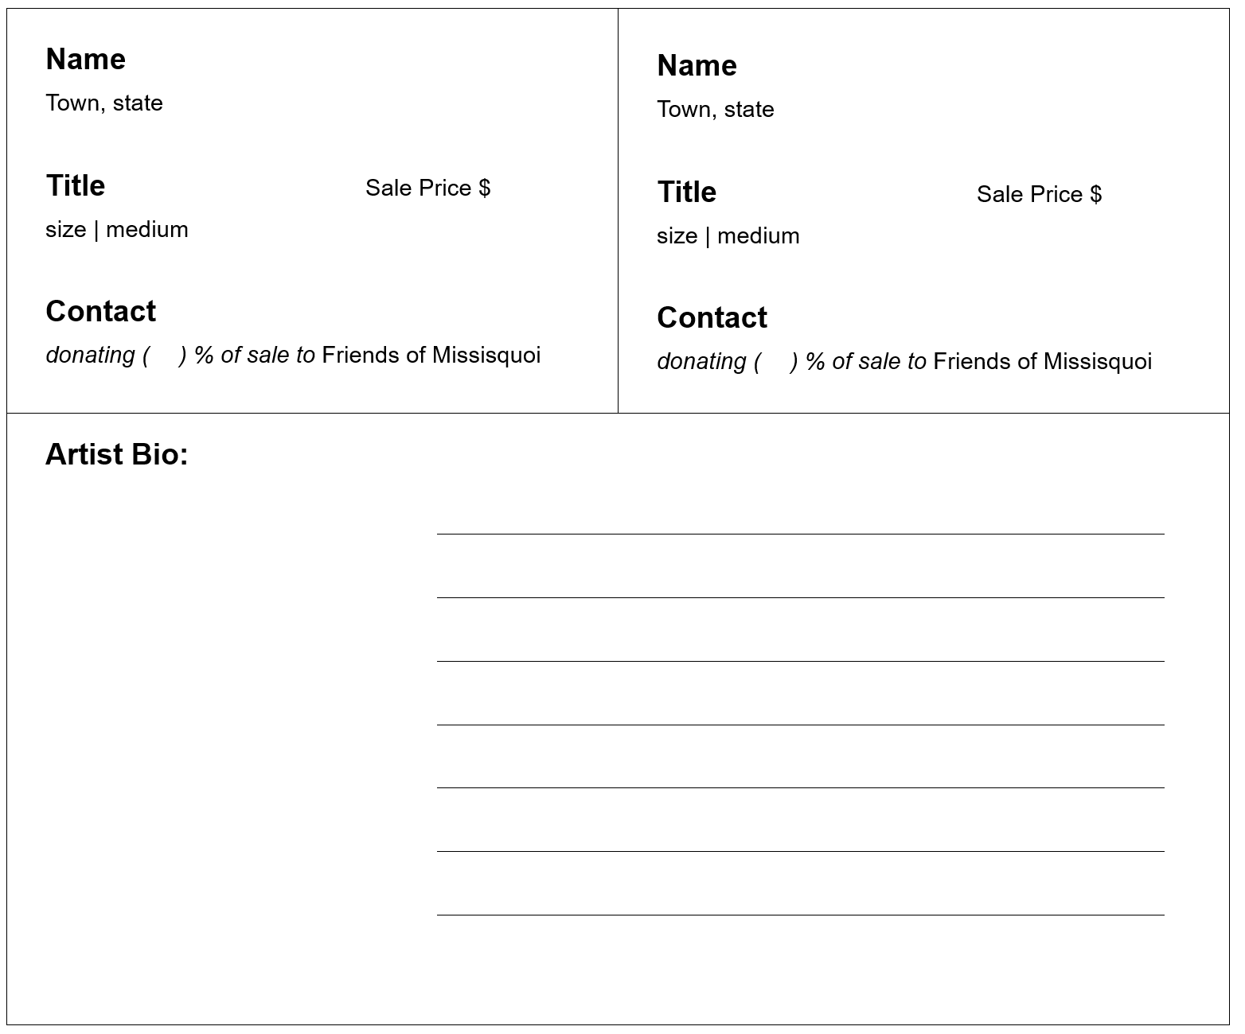

Included below is a complimentary ebird checklist to use as a list of birds found on the refuge or to use on your next birding adventure.

eBird Field Checklist
Missisquoi NWR IBA
Franklin, Vermont, US
ebird.org/hotspot/L109529
207 species (+24 other taxa) - Year-round, All years

Date:

Start time:
Duration:

Distance:

Party size:

Notes:

This checklist is generated with data from eBird (ebird.org), a global database of bird sightings from birders like you. If you enjoy this checklist, please consider contributing your sightings to eBird. It is 100% free to take part, and your observations will help support birders, researchers, and conservationists worldwide.
Go to ebird.org to learn more!

Waterfowl
Snow Goose
Canada Goose
Trumpeter Swan
Wood Duck
Blue-winged Teal
Northern Shoveler
Gadwall
Eurasian Wigeon
American Wigeon
Mallard
American Black Duck
Mallard x American Black Duck (hybrid)
Mallard/American Black Duck
Northern Pintail
Green-winged Teal
teal sp.
Canvasback
Redhead
Ring-necked Duck
Greater Scaup
Lesser Scaup
Greater/Lesser Scaup
Common Eider
Bufflehead
Common Goldeneye
Hooded Merganser
Common Merganser
Red-breasted Merganser
Ruddy Duck

duck sp.

Grouse, Quail, and Allies
Wild Turkey
Ruffed Grouse
Pigeons and Doves
Rock Pigeon
Mourning Dove
Cuckoos
Yellow-billed Cuckoo
Black-billed Cuckoo
Nightjars
Common Nighthawk
Swifts
Chimney Swift
Hummingbirds
Ruby-throated Hummingbird

Rails, Gallinules, and Allies
Virginia Rail
Sora
Common Gallinule
American Coot
Cranes
Sandhill Crane
Shorebirds
Black-bellied Plover
American Golden-Plover
Killdeer
Semipalmated Plover
Hudsonian Godwit
Short-billed Dowitcher
Long-billed Dowitcher
Short-billed/Long-billed Dowitcher
American Woodcock
Wilson's Snipe
Red-necked Phalarope
Spotted Sandpiper
Solitary Sandpiper
Lesser Yellowlegs
Greater Yellowlegs
Lesser/Greater Yellowlegs
Ruddy Turnstone
Sanderling
Dunlin
Baird's Sandpiper
Least Sandpiper
Pectoral Sandpiper
Semipalmated Sandpiper
peep sp.
shorebird sp.
Gulls, Terns, and Skimmers
Bonaparte's Gull
Ring-billed Gull
American Herring Gull
Great Black-backed Gull
gull sp.
Caspian Tern
Black Tern
Forster's Tern
Common Tern
tern sp.
Grebes
Pied-billed Grebe
Loons
Common Loon
Cormorants and Anhingas
Double-crested Cormorant
Herons, Ibis, and Allies
American Bittern
Least Bittern
Black-crowned Night Heron
Green Heron
Great Egret
Great Blue Heron
Vultures, Hawks, and Allies
Turkey Vulture
Osprey
Golden Eagle
Sharp-shinned Hawk
Cooper's Hawk
Sharp-shinned/Cooper's Hawk
American Goshawk
Northern Harrier
Bald Eagle
Broad-winged Hawk
Red-shouldered Hawk
Red-tailed Hawk
Rough-legged Hawk
Buteo sp.
Owls
Eastern Screech-Owl
Snowy Owl
Great Horned Owl
Barred Owl
Short-eared Owl
Kingfishers
Belted Kingfisher
Woodpeckers
Yellow-bellied Sapsucker
Red-bellied Woodpecker
Downy Woodpecker
Hairy Woodpecker
Downy/Hairy Woodpecker
Pileated Woodpecker
Northern Flicker
Falcons and Caracaras
American Kestrel
Merlin
Peregrine Falcon
Tyrant Flycatchers: Pewees, Kingbirds, and Allies
Eastern Wood-Pewee
Alder Flycatcher
Willow Flycatcher
Alder/Willow Flycatcher (Traill's Flycatcher)
Least Flycatcher
Empidonax sp.
Eastern Phoebe
Great Crested Flycatcher
Eastern Kingbird
new world flycatcher sp.
This field checklist was generated using eBird (ebird.org)
Vireos
Yellow-throated Vireo
Blue-headed Vireo
Eastern Warbling Vireo
Red-eyed Vireo
Shrikes
Northern Shrike
Jays, Magpies, Crows, and Ravens
Blue Jay
American Crow
Common Raven

Tits, Chickadees, and Titmice
Black-capped Chickadee
Tufted Titmouse
Larks
Horned Lark
Martins and Swallows
Bank Swallow
Tree Swallow
Purple Martin
Northern Rough-winged Swallow
Barn Swallow
Cliff Swallow
swallow sp.
Kinglets
Ruby-crowned Kinglet
Golden-crowned Kinglet
Nuthatches
White-breasted Nuthatch
Red-breasted Nuthatch
Treecreepers
Brown Creeper
Gnatcatchers
Blue-gray Gnatcatcher
Wrens
Northern House Wren
Winter Wren
Marsh Wren
Carolina Wren
Starlings and Mynas
European Starling
Catbirds, Mockingbirds, and Thrashers
Gray Catbird
Brown Thrasher
Northern Mockingbird
Thrushes
Eastern Bluebird
Townsend's Solitaire
Veery
Gray-cheeked/Bicknell's Thrush
Swainson's Thrush
Hermit Thrush
Catharus sp.
Wood Thrush
American Robin
Waxwings
Cedar Waxwing

Old World Sparrows
House Sparrow

Finches, Euphonias, and Allies
Pine Grosbeak
House Finch
Purple Finch
Redpoll
Pine Siskin
American Goldfinch
Longspurs and Snow Buntings
Snow Bunting
New World Sparrows
Chipping Sparrow
Field Sparrow
American Tree Sparrow
Fox Sparrow
Dark-eyed Junco
White-crowned Sparrow
White-throated Sparrow
Vesper Sparrow
Savannah Sparrow
Song Sparrow
Lincoln's Sparrow
Swamp Sparrow
Eastern Towhee
new world sparrow sp.
Blackbirds
Bobolink
Eastern Meadowlark
Orchard Oriole
Baltimore Oriole
Red-winged Blackbird
Brown-headed Cowbird
Rusty Blackbird
Common Grackle
blackbird sp.
Wood-Warblers
Ovenbird
Northern Waterthrush
Black-and-white Warbler
Tennessee Warbler
Nashville Warbler
Mourning Warbler
Common Yellowthroat
American Redstart
Cape May Warbler
Cerulean Warbler
Northern Parula
Magnolia Warbler
Bay-breasted Warbler
Blackburnian Warbler
Northern Yellow Warbler
Chestnut-sided Warbler
Blackpoll Warbler
Black-throated Blue Warbler
Palm Warbler
Pine Warbler
Yellow-rumped Warbler
Black-throated Green Warbler
Canada Warbler
Wilson's Warbler
new world warbler sp.
Cardinals, Grosbeaks, and Allies
Scarlet Tanager
Northern Cardinal
Rose-breasted Grosbeak
Indigo Bunting
Others
passerine sp.

This field checklist was generated using eBird (ebird.org)

